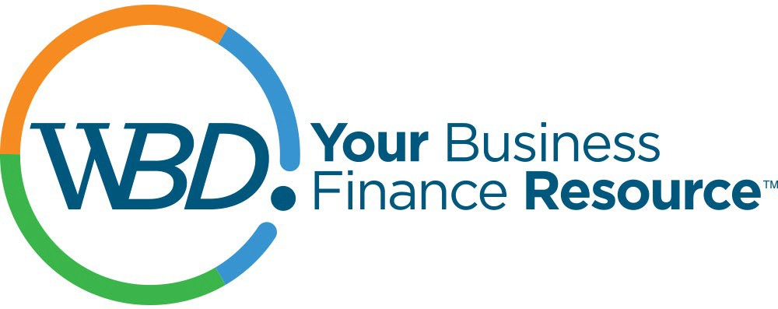

WBD Opportunity Fund Application

Supporting efforts aligned with our mission to grow businesses, create jobs and build communities.

INSTRUCTIONS: Submit requests and include all the following information, indicating anything not applicable to your organization. The deadline for consideration for funding this year is August 1, 2022. Applications submitted after this may be considered for the following year.

Note: All final reporting must be submitted as requested to avoid ineligibility for future investments.

Date: Amount Requested: $
Organization name: Tax ID#:
Address, city, state, zip: Contact Name: Title:
Phone: Email:
Project Name:

Attach proposal narrative including information on the following:

- Please provide a narrative of your project (500 words max) (Clear, concise project description, stated goals and target audience, use of funds clearly defined)

- What is the expected outcome of your project? How will you measure your success? (Project describes what metrics will be used to show the impact of the project?)

- Please provide information on your project timeline? When do you expect to implement your project and see results?

- What is the likelihood of this project moving forward without WBD funding? (Response provides a strong argument as to why funds are needed)

- Describe any innovative, unique, novel, aspects of your project.

- What is the geographic reach of your project? Can it be replicated in other areas?

- Will WBD’s investment be combined with other funding sources? If so, please elaborate.

- Please provide any other information you believe would be helpful in our consideration of your request.

Please check all that apply to your project:
- Serves a large number of “customers” (entrepreneurs/small businesses)
- Solves a problem
- Creates jobs (estimated number_____)
- Retains jobs (estimated number_____)
- Able to document metrics/measurement of success
- New or innovative project
- Project would not happen without or “but for” WBD support
- This project could be replicated in other areas of the state?
- Have other organizations provided financial support?
- Project serves/assists low- or moderate-income audiences
- Project serves women, veterans, BIPOC or other marginalized individuals
- Partners with other technical assistance providers, organizations, local partners

I certify that any support from the WBD Opportunity Fund will be used as indicated in this application

Signed:
SUBMIT Proposal and this completed form to;
WBD, Inc.,
4618 S. Biltmore Lane,
Madison WI 53718

OR by email to OpportunityFund@WBD.org August 1, 2022. Questions? Contact Lance Walter at 608-316-7156.

